4. Find Applied Couples that Produce Desired Bending Stress and Deflection

Geometry: Length = 30, Height = 2 Material: E = 10⁵ (1E5), ν = 0.3.
Mesh: 30 by 1 Quad elements.
Loads:
- Cantilevered at the left end (Ux = Uy = 0 on all nodes at left end).
- Three couples are applied along the length. In FEA apply a couple at a cross-section by applying equal and opposite forces Fx on the top and bottom nodes of that cross-section. You are to determine the couples as follows.

Here is an example of applying a moment of 1000 clockwise to the beam:
500
2

500

The three applied couples will have magnitudes 2800, 1200 and 2200. The points of application are at cross-sections x = 10, 20, and 30. Your goal is to determine the magnitude (2800, 1200, or 2200) and the direction of the couple (clockwise or counter- clockwise) at each of these three cross-sections. Your choice must satisfy both of the following conditions:

1. The deflected shape of the body appears as that shown below.

2. When you analyze the body as a cantilevered beam under your chosen applied couples, the maximum stress is 2400.

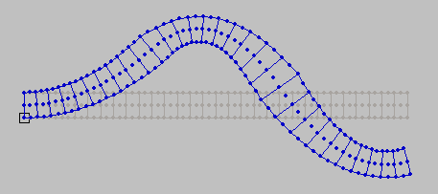

Hints: Think about the direction of curvature in each part of the beam, and think about the internal bending moment at different cross-sections of a beam when you have several couples applied along the length of the beam.

Once you have found suitable values and directions for the couples do the following:

- Copy and print out the deformed shape for your loads.

- Draw the beam problem with the cantilever support. Draw the couples you applied to the body, with magnitudes and positions labeled.

- Draw the shear force and bending moment diagrams for the beam with your loads.

- Determine the bending stress at the bottom of the beam (y = 0) at x = 5, 15 and 25 using beam theory and then compare with the stress from the FEA.

Draw a cantilever beam with your final choices for the applied couples. Below it, draw the shear force and bending moment diagrams

Show the values of the terms in your calculation of stress from beam theory σ = -My/I.

Enter values of stresses
 | (5,0) | (15,0) | (25,0)
σ_{x} (Beam theory)
σ_{x} (FEA)

